Smart Washroom IoT device demo & installation @RSP- Rourkela Steel Plant (SAIL) - Tour Details

Smart Washroom - IoT Device - Brief:

Our innovative IOT-based smart washroom device, designed specifically to ensure cleanliness in industries and organizations. Equipped with precise sensor, our device can detect bad odor in washrooms, transmits data to an IoT cloud and if it is too dirty the device can immediately send notifications to cleaning staff for timely attention.

Furthermore, the device has been designed to control the on/off function of exhaust fans, ensuring maximum energy efficiency. In cases of bad odor, the device activates the perfume dispenser, effectively reducing unhygienic conditions caused by bad odor.

Our smart washroom device can be easily managed through a single dashboard, allowing for easy monitoring and control of all functions and parameters. This feature enables conditional monitoring and scheduling of washroom cleaning, providing a safe and convenient environment for all users.

Our product is a part of the "Swachh Bharat Abhiyan" initiative, contributing to the Make in India campaign. With our smart washroom device, we are committed to promoting hygiene and cleanliness in all industries and organizations.

Specifications and Features:
- Voltage Input : 5volt DC , USB C-Type
- Max Current : 300mA
- Output Device switching : 4- channel Relay (230V AC, 10A, 50Hz)
- Weight: 175gms
- Dimennisions: 80mm x 55mm x 15mm
- Operating Temperature: 20 to 40 C
- Sensitive to VOC’s and perfumes
- SIM : Airtel 2G network only, NANO sim Slot.
- SMS alerts per day : 100 SMS(as per recharge plan)

IoT Application:

- Publish and update data to Thingworx IoT cloud platform.
- User friendly Central Dashboard to monitor real-time status of all smart washrooms with saniTECH
- Historical data plots, Dynamic icons with UI/UX Graphics.


CSED start-UP Hosting - SCET

Dashboard Link: saniTECH RSP-SAIL http://thingworx.scetngp.com/Thingworx/Runtime/index.html?mashup=RSP_SmartWashrooms_dashboard&forceClose=true&__enableBMF=true&__fromNextGen=5381a583-cf17-450c-ad38-21f50ca83ec1&features=

Demo and Installation at Rourkela Steel Plant (SAIL- Maharatna) - Central Govt. Public sector unit

Tour Details :
Sl.No | DATE | TIME | Event Description
1 | 16th july 2023 | 6 AM | Started with SCET college team by road (Innova car)
2 |  | 11 PM | Reached SAIL - Hill view Gust House
3 | 17th July 2023 | 9 AM | Met Samgram sir - SAIL employee
4 |  | 10 AM | Reached SAIL - RSP Main gate for Gate pass
5 |  | 11 AM | Meeting with SAIL - RSP Executive director(ED)
6 |  | 12 AM | Smart Washroom Product Display and Demo to top officials at RSP - explaining its importance and features
7 |  | 1 PM | Sketching a plan to install device at allocated washrooms in ED Admin Building
8 |  | 3 PM | Installation Done at First floor ED office common washroom
9 |  | 4 PM | Installation Done at Ground floor common washroom
10 |  | 5 PM | Smart Washroom Device configuration, Threshold values settings and Code customization
11 |  | 5:30 PM | Live demonstration and SMS alerts verification by top officials
12 |  | 6 PM | Succefull Installation and testing - Appreciation from ED, HR and top officials
13 |  | 8 PM | Success Meet and official dinner with SAIL - RSP Executive Director’s Family
14 | 18th july | 11 AM | Smart Washroom Real- time observation and few required modifications as requested by SAIL team
15 |  | 5 PM | Meeting - Noted Additional Requirements and Add- On features to Smart Washroom device
16 | 19th July | 7 AM | Started Return Journey
17 | 19th July | 11:55 PM | Reached SCET College

Smart Washroom Device Installation photos and videos:

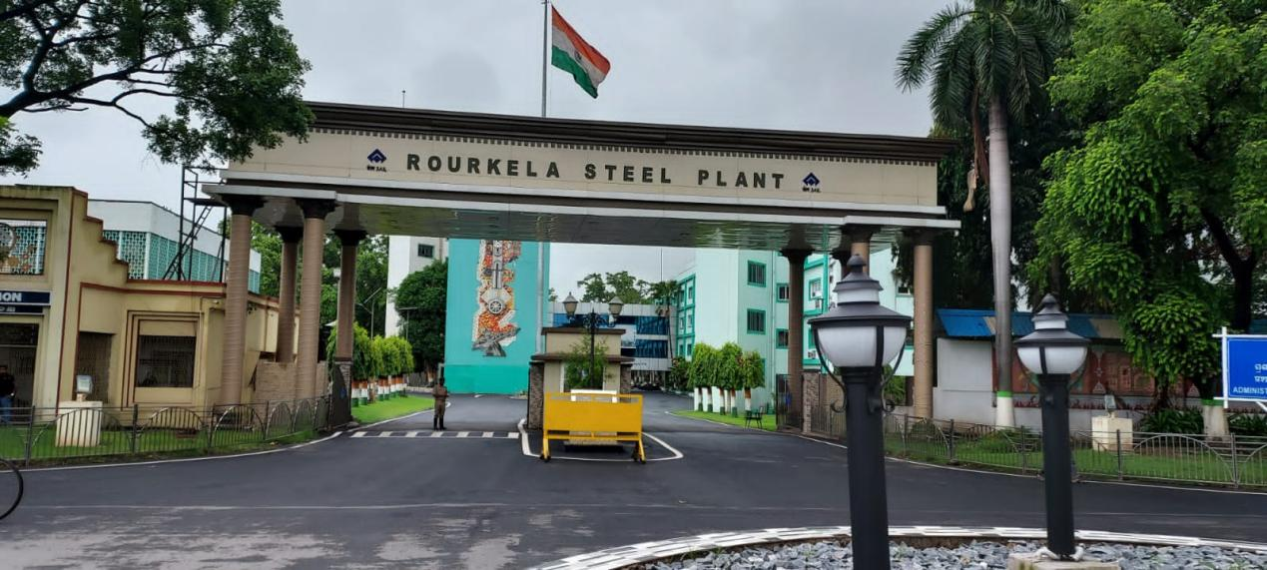
Roukela

